Jack Johnson

August 19, 2021

Phase End Project: Online Test Application

Link to my GitHub repository: <https://github.com/jjohn98/2058519_Jack_Johnson_Mean_Stack>

This project is located in ~/Phase2/online-test-app.

In this project, I created 1 component to handle the app itself, and everything is done within this component. The test-main.component.html handles the inputs to the test as well as submitting and portraying data. The test-main.component.ts handles the processing of data such as reading in the questions from the questions.json file located in the assets folder, and updating the correct answers once the user has finished the test.

In the module file, all I had to do was add FormsModule to the list of imports.

My webpage does look very barebones as I was starting to run low on time when I finally figured everything out and want to make sure I turn in the project on time. I could easily make the whole thing have a better look and feel if I just had a little more time.

The files for this project will be in the GitHub repository, as well as the source code section of the submission on Simplilearn.

Screenshot of Web pages created:

**Main page (test-main.component.html):**

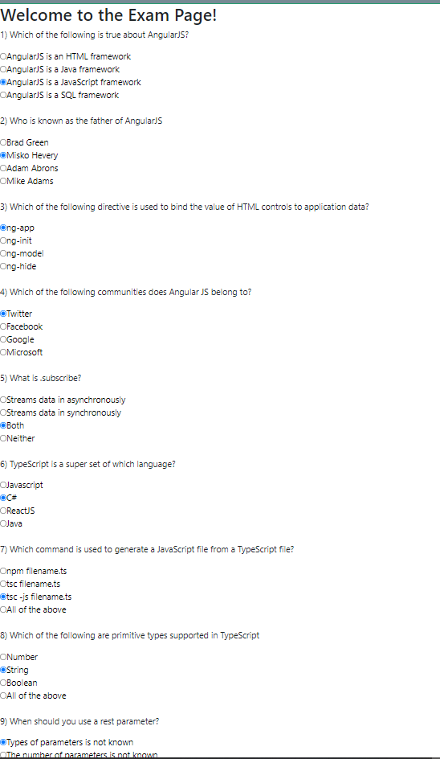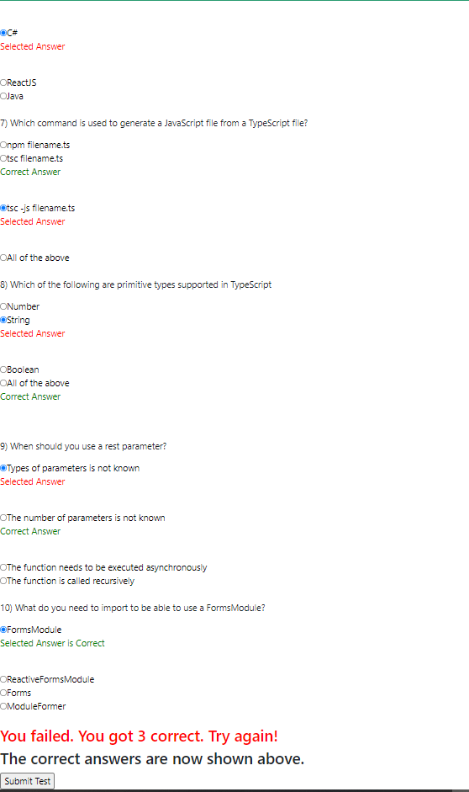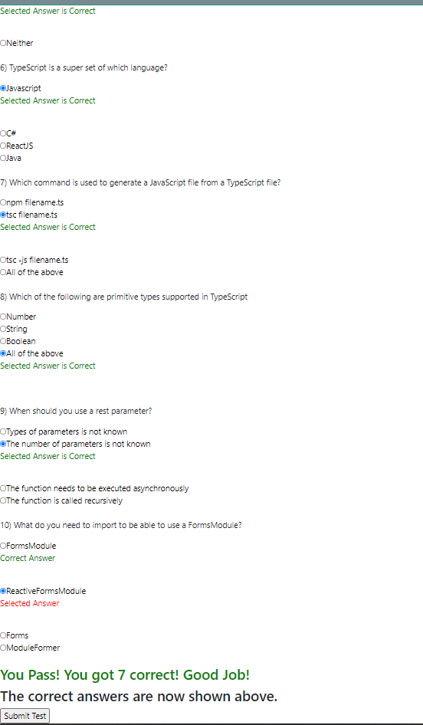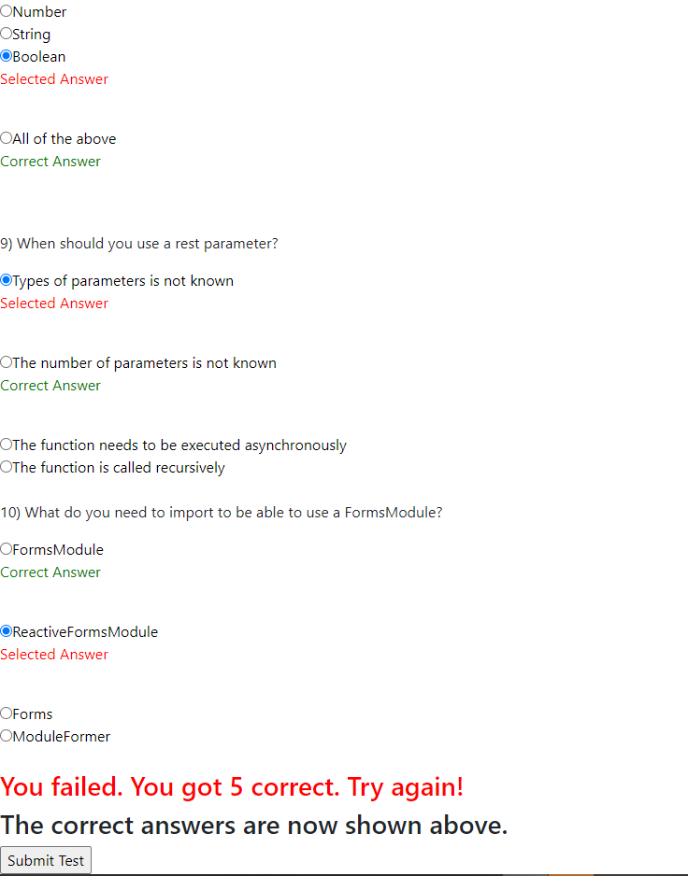

With all correct answers:

